Reci-Please

[Date]

Group members:

Zachari Nicholls – z5349535@ad.unsw.edu.au

Michael Anderson – z5349512@ad.unsw.edu.au

# Introduction

Brief explanation of the project and its functional requirements (you may refer to information from Project 1 if necessary)

# Live Application

Link to the live application (front-end and back-end integrated and fully functional)

# User Manual

User manual on how to use the APIs and any other important details, such as user login credentials to test the application

# API Application Details

URL address or IP address to the API application

# Fully Functional Application

URL address or IP address to the fully functional application

# GitHub Repository

Throughout this assignment both members of the group have obtained a drastic improvement in their ability to utilise GitHub. Prior to this assignment we have both not been proficient in its ability to assist in the maintenance of a project. However; we have begun to utilise it to it’s strengths and now are happy with how GitHub is used.

You can access our repository through the following link:

https://github.com/zac-ari/Reci-please.git

# Readme file information:

## Team members (including their email addresses)

## Project description

## Running the project instructions

# Cloning and Running the Application Locally

## Instructions on how the course convenors can clone and run the application locally

# Functional and Security Testing

## Explanation of the process of functional and security testing

## Testing APIs using Postman

Refer annex A for the testing documentation.

## Screenshots as evidence of successful testing

**Annex A – Testing**

We conducted our testing in a phase approach utilising Postman – These phases where create, read, update, and delete.

Phase one

To begin with I ensured that all data was removed from the database, as can be seen through Laragon in figure 1. Additionally figure 2 shows a Postman search whilst the tables are empty. Once this was established we then conducted several creates with basic and self-explanatory data for the inputs. *Note* at this point we are not doing edge testing, merely functionality and error handling.

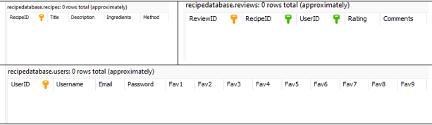

Figure :Empty tables

Figure : Getting all 3 tables whilst empty

After we have ensured that the tables are empty and the searches are returning this information we moved on to testing the create functionality. Additionally, once data was created in the tables we tested the search function again with specified and broad information. Figures 3, 4 and 5 show the creation function working. Figures 6, 7 and 8 show the search function working for the created data.

Figure : Recipe creation

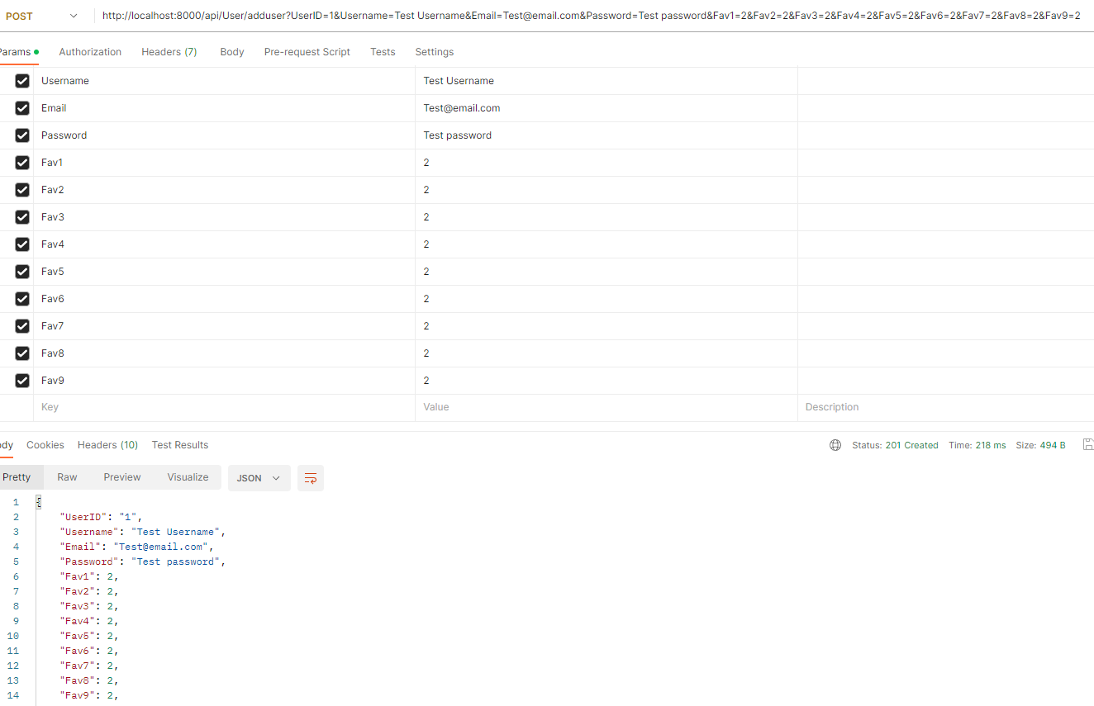

Figure : User create

Figure : Review create

Figure :RecipeID2 search

Figure :UserID2 search

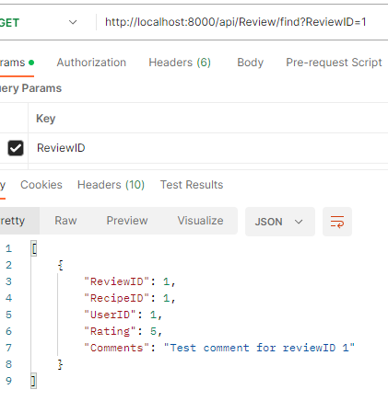

Figure :ReviewID1 search

After we have tested both the search and create APIs we moved onto update. Because we already have existing data in the table we checked if we could update it to change its data.

Figures 9, 11 and 13 show this working, with 10, 12 and 14 showing the respective search to show that the update worked.

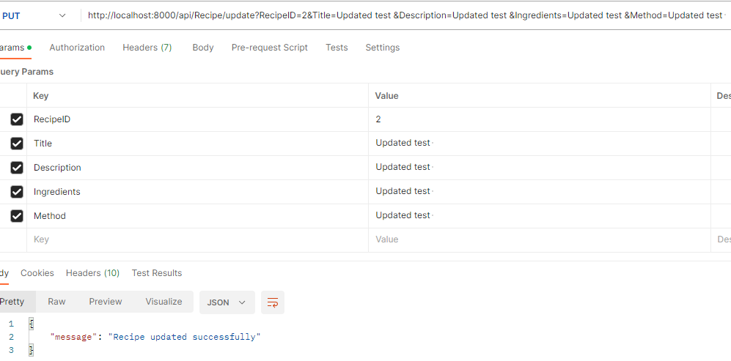

Figure : updated recipe 2

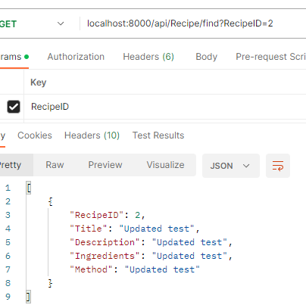

Figure : updated search

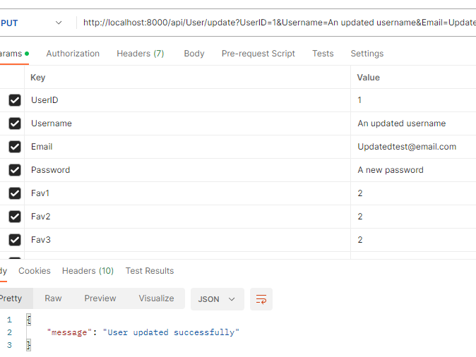

Figure :user 1 update

Figure :Updated user search

Figure : Update to review

Figure :Updated search for review 1

Now that everything has worked so far it is time to test the deletion. Noting the interrelationships of the